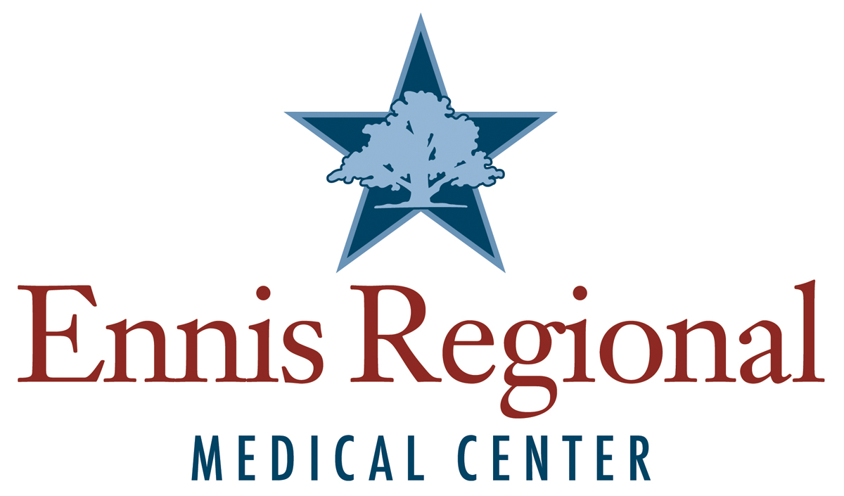
Community Health Plan of Care

Created: July 2022
Committee Approved:
Ennis Regional Medical Center
Community Health Plan of Care
2022
Introduction
Ennis Regional Medical Center (ERMC) strives to provide a comprehensive strategy to meet the healthcare needs of our community and Ellis County. ERMC’s Chest Pain Committee is purposed with planning and implementation of events and services to meet the needs noted on the community health needs assessment (CHNA). Ellis County does not have a community health department, so we reached out to Methodist Mansfield Medical Center (MMMC) to utilize the CHNA they released in 2020. ERMC has entered into a transfer agreement with MMMC in a one call STEMI plan. This agreement has proven beneficial in improving outcomes for Acute Coronary Syndrome patients in our community. ERMC has formulated our community health plan of care utilizing the MMMC CHNA and historical data from CHNA’s used by ERMC in the past.
Objectives and Vison
- ERMC seeks to provide a comprehensive assessment of our community and Ellis County’s health needs and risk identification
- ERMC will utilize the community health needs assessment provided by MMMC and historical data to identify priority needs of our community.
- ERMC will utilize the data from these sources to provide printed, oral and educational medias to educate our community and Ellis County on the identified health care needs and risk.
Identified Priority Education for Community Risk Factors
- The MMMC CHNA identified the following health care needs to be addressed:
  - Atrial fibrillation
  - Obesity
  - Diabetes
  - Opioid Addiction
  - Cancer
- The past CHNA ERMC has utilized identified the following health care needs:
  - Obesity
  - Diabetes
  - Healthy Eating and Physical Activity
  - Heart Disease
  - Hypertension
  - Asthma
- Based on this data, ERMC chooses to prioritize the following health care needs. Based on ERMC’s capabilities and services provided, we can have the best impact on meeting these needs.
  - Obesity – Healthy Eating and Physical Activity
  - Heart Disease
  - Hypertension
Implementation Strategies
- Priority #1: Obesity – Healthy Eating and Physical Activity
  - ERMC will provide educational materials to the community, on the risk of obesity and benefits of healthy eating and activity at community health fairs, ERMC social media pages, ERMC educational TV monitors located in our waiting rooms, and to our patients and families with consultation from our dietician. Our cardiac rehab program provided education to each patient in the program.
- Priority #2: Heart Disease
  - ERMC will provide educational materials to the community, on the risks and identification of heart disease at community health fairs, ERMC social media pages. EHAC and Hands Only CPR will be presented at community events throughout the year. Our cardiac rehab program provided education to each patient in the program.
- Priority #3: Hypertension
  - ERMC will provide educational materials to the community on hypertension at community health fairs and ERMC social media pages. ERMC performs Blood Pressure screening at community events such as Ennis ISD annual athletic physicals, ERMC Friends (Senior Citizen group) and other events throughout the year.
Partnerships
- ERMC partners with the following organizations to implement our Community Health Plan of Care
  - American Heart Association
  - Ennis Chamber of Commerce
  - Unity in the Community
  - ERMC Friends
  - Local Churches
  - Community Members
  - Patients
  - Ennis ISD
Action Steps
- ERMC will take the following action steps to implement our Community Health Plan of Care
  - Use written materials for handouts
  - Place educational offerings on our website: EnnisRegional.com
  - Social Media Postings
  - Attend community events, such as the National Polka Festival, Bluebonnet festival.
  - Blood Pressure screenings at events
  - Hospital Education TV monitors in Waiting Rooms

Anticipated Impact
- Decrease the percentage of obesity and increase physical activity and exercise in our community.
- Increased early recognition of signs and symptoms of heart disease, with increase in seeking care and treatment.
- Early recognition of hypertension and treatment options
Quarterly Events-Education Screenings
- First Quarter 2022
  - Monthly ERMC Friends Blood Pressure Screening and Hands only CPR
  - Social Medial Pages “28 Days of Heart Health”
  - American Heart Association “Go Red” Recognition
- Second Quarter 2022
  - Monthly ERMC Friends Blood Pressure Screening and Hands only CPR
  - Ennis ISD Athletic Physicals Blood Pressure Screening
  - Annual National Polka Festival EHAC and Hands Only CPR
- Third Quarter 2022
  - Unity in the Community Health Fair Blood Pressure Screenings, EHAC and Hands Only CPR
- Fourth Quarter 2022
  - Monthly ERMC Friends Blood Pressure Screening and Hands Only CPR
  - Annual ERMC Friends Health Fair – Blood Pressure Screenings, Flu Shots, EHAC and Hands Only CPR (Partners with AMR EMS)

